Suitability of Austin Apartments

Introduction
The population of the City of Austin, Texas has grown seventeen percent from the year 2000 to 2010 and have grown by forty percent from 1990 to 2010. This influx of population creates the problem of where do the new comers live based to distance to schools, hospitals, culture rental prices.

Scope
My Study area is the City of Austin and my objective of this project is to find the most suitable areas of Austin to live based on the factors of proximity to school, hospitals and culture, while at the same time using rental prices to show the more inexpensive regions of the city. The assumption being new arrivals to the city will want easy access to facilities and schools while also being able to afford to live in the city. With average rent in Austin being 1100 dollars a month new arrivals would need to know the cheapest place to live based on distance to schools, culture and hospitals.
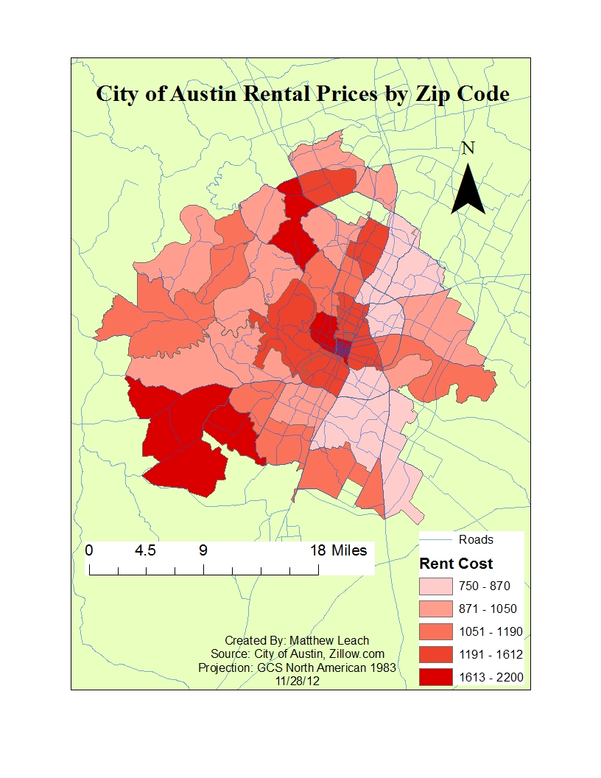

The reason these criteria were chosen for my project are a follows. Rental price: first because money is always an issue, especially with new immigrants to a city who may be on a budget and may not have a steady income yet. The next criteria I used was schools, for which many newcomers have moved to Austin. The third factor I used was culture which is theatres, parks and music halls in the city to provide entertainment for city residents during their leisure. The last variable I used was hospitals, which I consider a safety and health concerns of all city residents’ especially new comers who being close to a clinic or hospital can save lives and increase peace of mind. Furthermore being close to all these factors could be important in terms of employment because these facilities are some of Austin’s largest employers.
a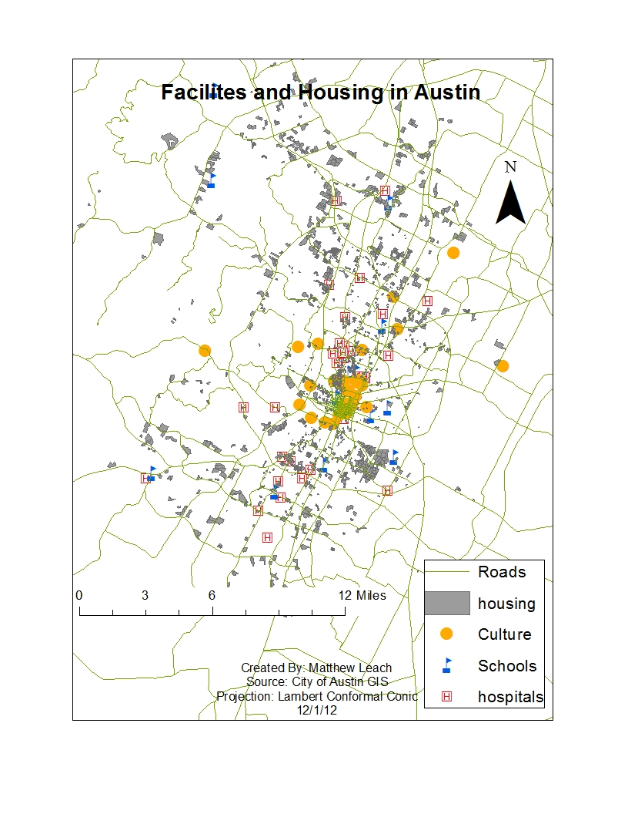

Methodology
After deciding the criteria for my project, I collected the data. I found locations of the facilities and housing in the city and mapped them out. I drew four mile buffers around the schools, hospitals and cultural places and reclassified them with a one if they fell within the four miles and a zero if they failed to meet this distance requirement. The distance of four miles was chosen because it is just close enough to walk to, and short bus ride or car ride, which I decided is a suitable distance. The rental properties presented the biggest challenge to me. After going through the land use data from the City of Austin and removing the” Apartment” attribute out of hundreds I still had to find rental prices. I decided to use the Zip Codes as my rental price factor, by going to Zillow.com I found the average rent per zip code. Next I manually entered the average rent for every Zip Code in Austin then preformed a spatial join of my Zip Code data with my Apartment data creating a new layer. Next I reclassified this new rental price layer with a one if it was 1100 dollars or less a month and a zero if it was more, leaving me with Apartments that were most affordable. The last step in my model was to put all my reclassified data (hospitals, schools, cultural centers and housing) into the raster calculator to reveal the most suitable (pass/fail) apartments around the city based on all my factors.
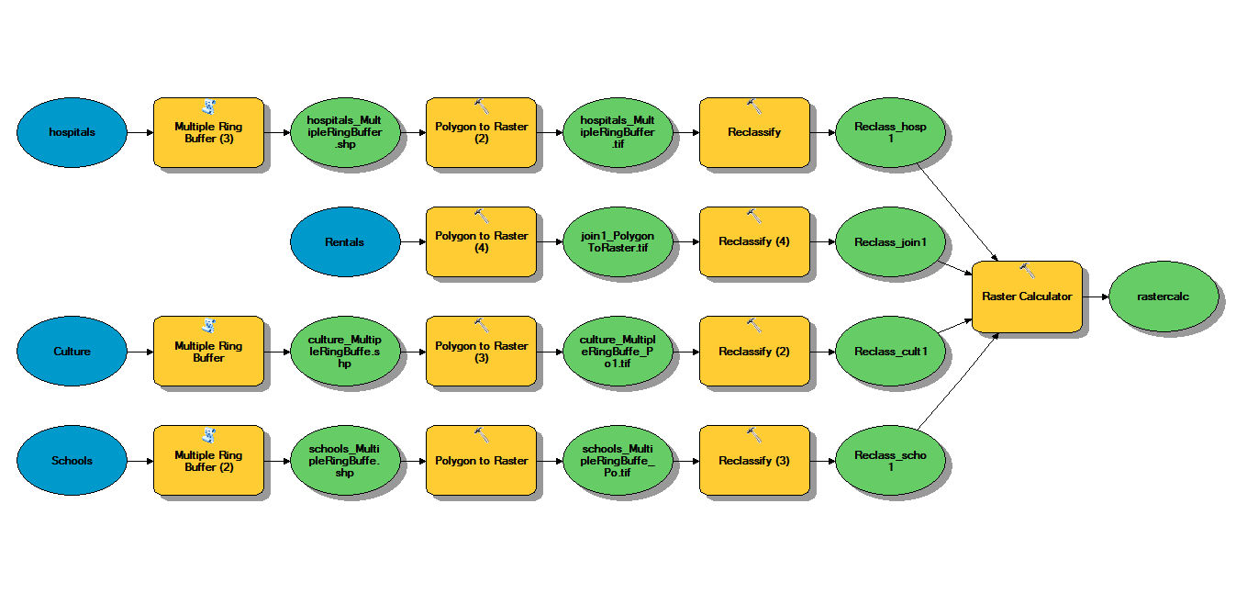

Conclusions
I found that out of 40,512 units of housing only 4,195 passed. Many of these units were not in the center city which traditionally is the most expensive part of the city, but many were closer than I would have thought. The majority of the housing that passed using my criteria were just south of the center and further North to Northeast of downtown, with a few outliers in the Northwest. The findings that only ten percent of Austin apartments met my specific distance and price level is not a positive endorse of Austin making available suitable residences for new, potential and current residents of the city. My findings show that land lords and rental property owner need to lower prices so the city can continue to grow as it has over the past twenty years. Solutions could be rent controls for the city when income doesn’t increase, or a less invasive action could be to subsidize housing to land lords that have lower prices or even make available more city sponsored housing to new residents. If the City of Austin wants to retain its population growth it must make more housing affordable in areas where it is needed. This model is useful for city planners as well as private sector developers to know where to build new units or promote assistance to lower prices.
Criticisms of this project were the lack of more specific data. Housing data didn’t allow me to see what units rented or not resulting in apartment’s buildings that didn’t pass my criteria test, but might not have any available rooms to rent. Also only using Zip Code average rents limited me to larger study areas then I would have liked. A more precise model could have been done if I would have had rent average per neighborhood or census tract. This could have made for an even more accurate picture of the best place for people to live.
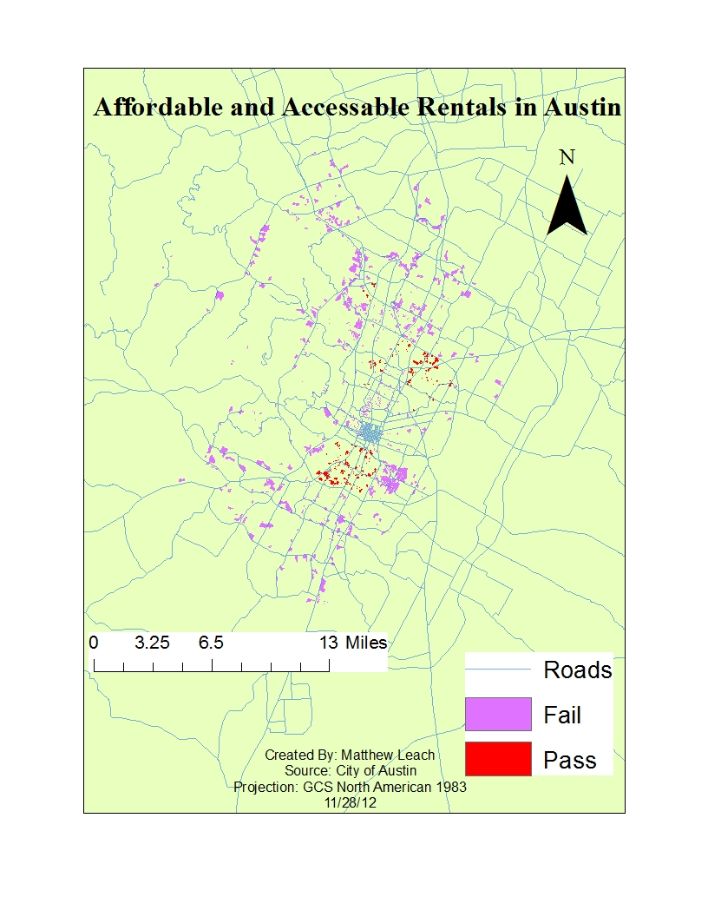

References:
City of Austin GIS, : ftp://ftp.ci.austin.tx.us/GIS-Data/Regional/coa_gis.html
Zillow, : http://www.zillow.com/

